

**TUNKU ABDUL RAHMAN UNIVERSITY COLLEGE**

FACULTY OF COMPUTING AND INFORMATION TECHNOLOGY

BAIT2133 WEB ENGINEERING

PRACTICAL 3

Read the case study:

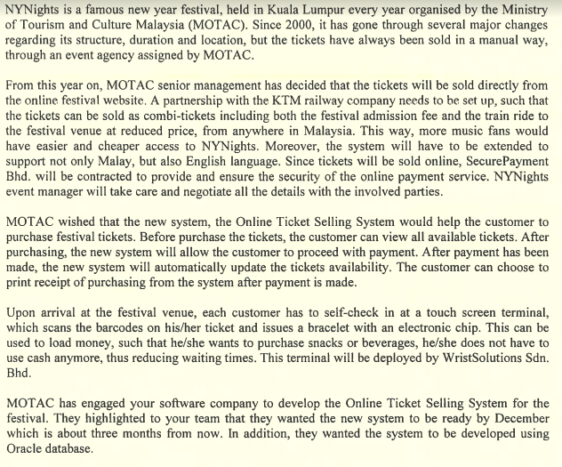

1. Draw the use case diagram for MOTAC system.

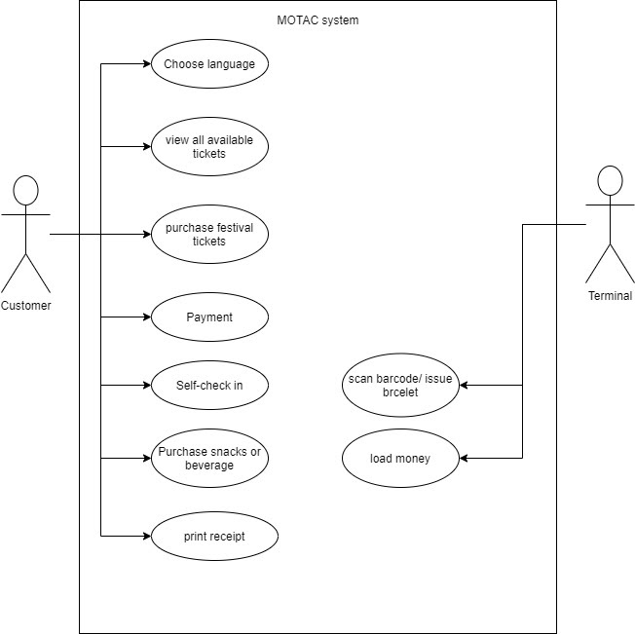

2. Provide description for the use cases.

|  |  |
| --- | --- |
| 1. Use case name: Purchase festival ticket 2. Brief Description: To let customer to purchase the festival ticket 3. Actor: customer 4. Pre-condition: They have credit card 5. Main flow: | |
| Actor Action | System Response |
| 1. Enter the online selling ticketing system | • Show the interface for selecting language |
| • Choose language | 3.   Show the interface for ticketing system |
| 1. Click the view all available tickets button | • Show all available tickets. |
| • Choose the ticket and enter the amount | • Calculate the final price and proceed to payment |
| • Purchase the ticket |  |
|  | 1. Update the ticket availability |
|  | 1. Generate receipt |
| • Print receipt |  |
|  |  |
| 6. Alternative flow:  A1. If step 8 is invalid will return to step 5 and show the error message | |
|  | |
|  | |

|  |  |
| --- | --- |
| 1.Use case name: self-check  2.Brief Description:load money  3.Actor: customer  4.Pre-condition: they want to load money  5.Main flow: | |
| Actor Action | System Response |
| 1. Scan the barcode | • Verify the barcode |
|  | 3.show  success self-check |
| 4.Enter the amount | 5.Comfimation the amount |
|  | 6.check the payment status and load the money |
|  | 7.print the receipt |
| 8. Click the check amount button | 9. Display the amount success |
| 6. Alternative flow:  A1. If step 6 is not invalid will return to step 1 and display invalid message | |
|  | |

3. Identify the functional requirements from the scenario.

4. Identify the possible non-functional requirements.